

TUDU Merchandise
Strategy & Direction Document

1. Overview
TUDU Merchandise extends the brand beyond the app and into the physical world — plush toys, backpacks, apparel, calendars, keychains, and more, built around both the core TUDU brand and the Tuduans character roster. Merchandise gives users a way to carry TUDU with them, gives the Tuduans a physical presence kids can hold onto, and creates a retail layer that connects naturally to the TUDU Event Marketplace, TUDU Miles, and the TUDU Kids Foundation.

2. Product Line

2.1 Plush Toys
Soft, huggable versions of the five Tuduans — Sol, Lumi, Ember, Nova, and Axis — each true to its character's color palette and motif. Plush toys are the most direct extension of the character universe and a natural anchor product for both retail sales and TUDU Kids Foundation giveaways.

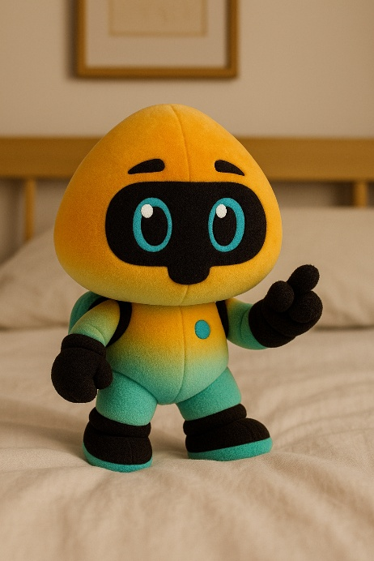
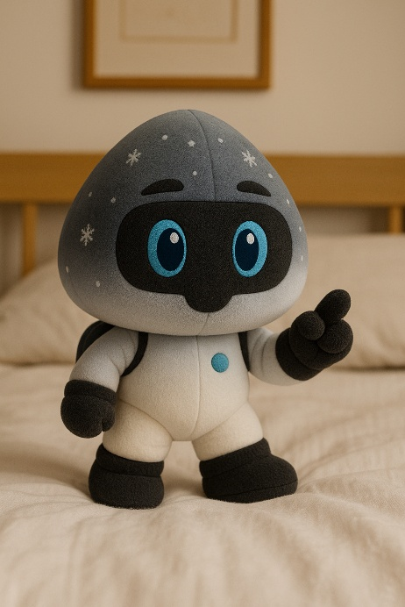
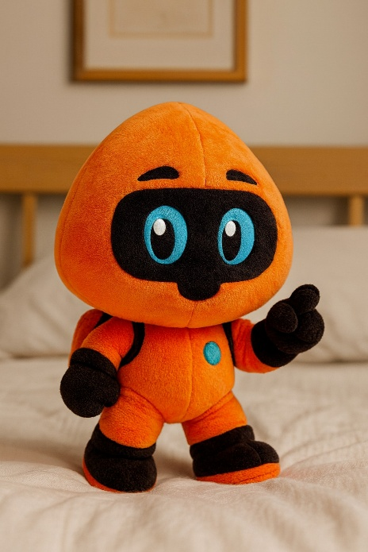

2.2 Backpacks
Character-shaped backpacks modeled directly on the Tuduans, designed for kids: plush-soft construction, a spacious main compartment, front zip pocket, side pockets, adjustable straps, and durable, kid-ready materials.
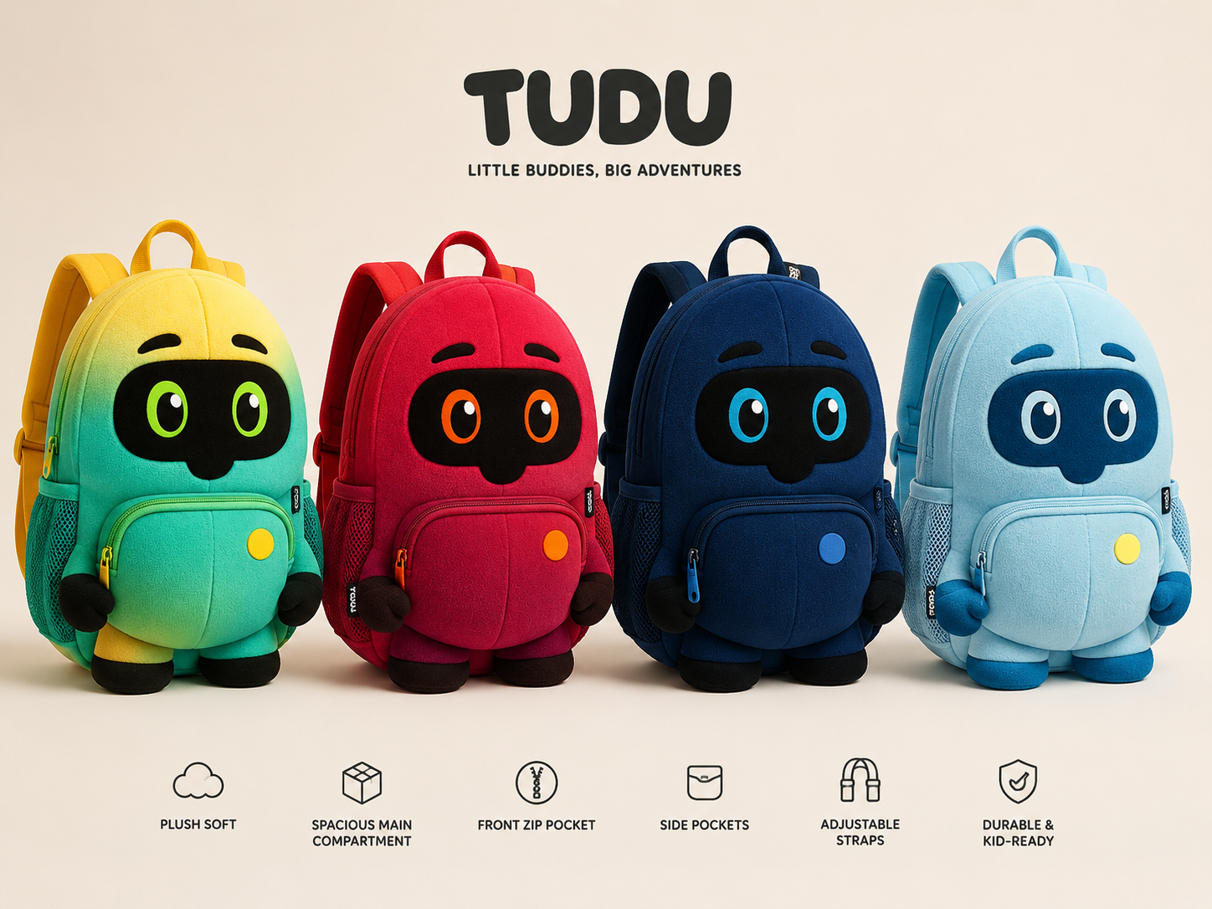
TUDU character backpacks — "Little Buddies, Big Adventures"

2.3 Calendars & Stickers
A large wall calendar featuring the full Tuduans lineup, paired with reusable event stickers so kids (and families) can plan out and mark the adventures they want to have — directly reinforcing TUDU's core "discover and do" mission in a physical, everyday object.
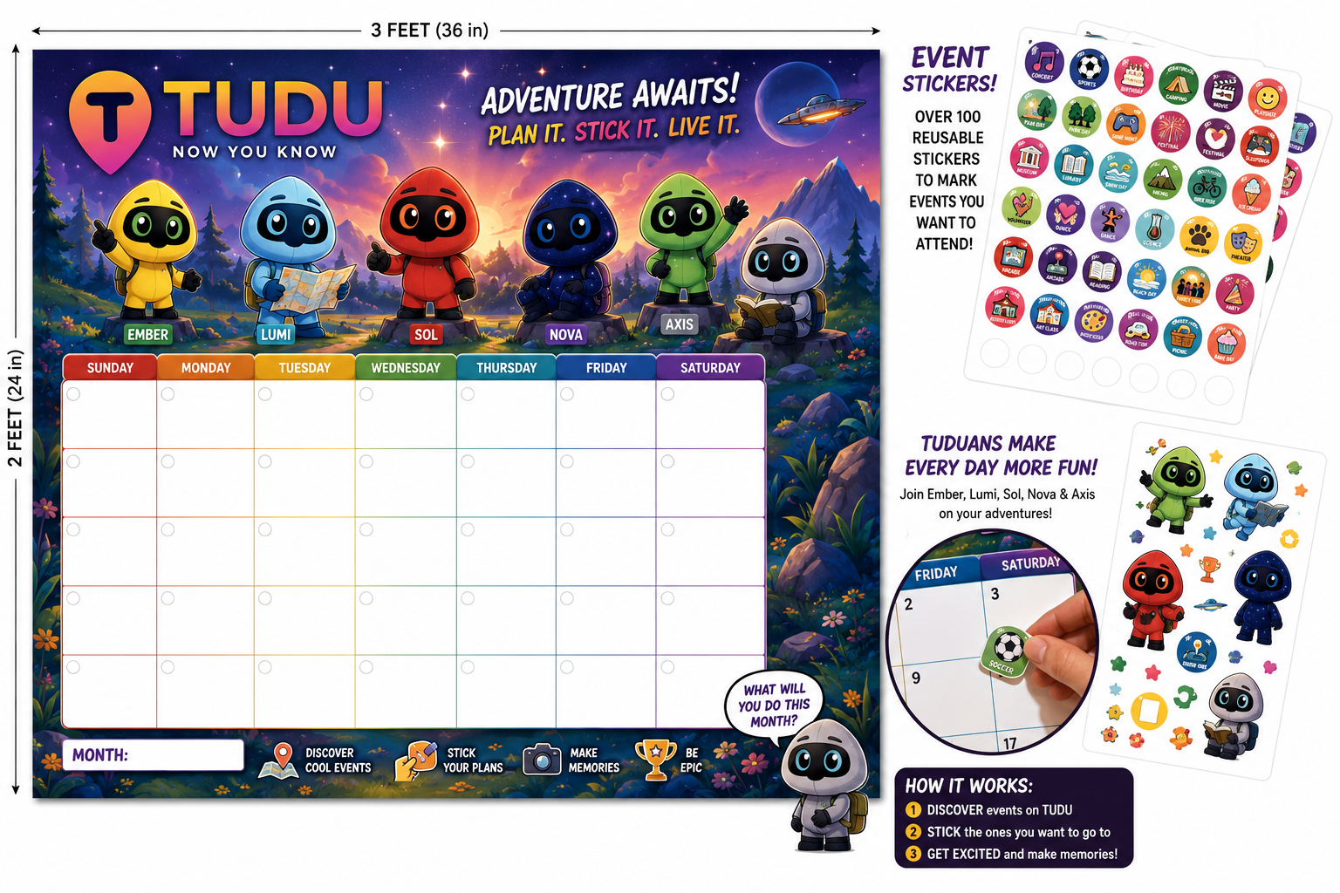
TUDU wall calendar with reusable event stickers — "Plan It. Stick It. Live It."

2.4 Adult / Brand Apparel
Clean, brand-forward apparel for adults — t-shirts and hoodies featuring the TUDU wordmark and pin logo, geared toward everyday wear, live events, and TUDU Crew branding.
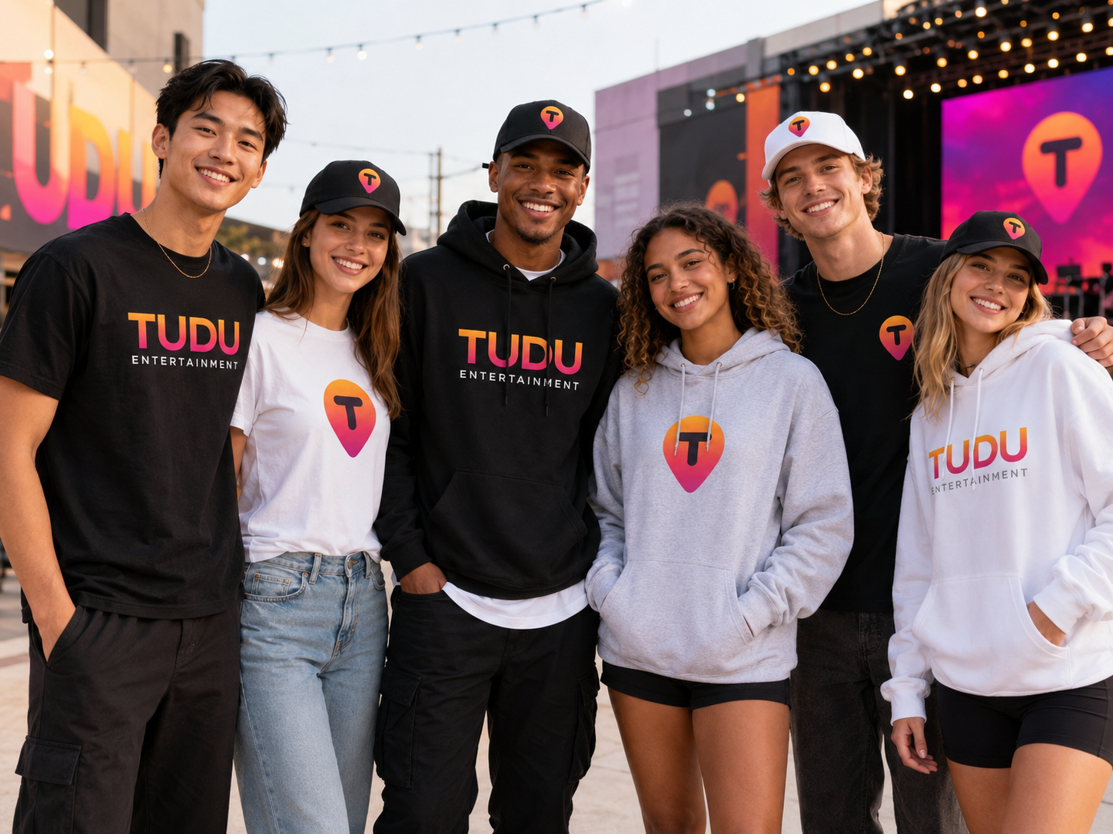
TUDU Entertainment adult apparel — t-shirts and hoodies

2.5 Youth / Character Apparel
Apparel aimed at kids and younger fans, featuring individual Tuduans (Nova, Ember, Axis, Sol) as standalone character graphics, alongside standard TUDU branding — giving young fans a way to represent their favorite character specifically, not just the brand as a whole.
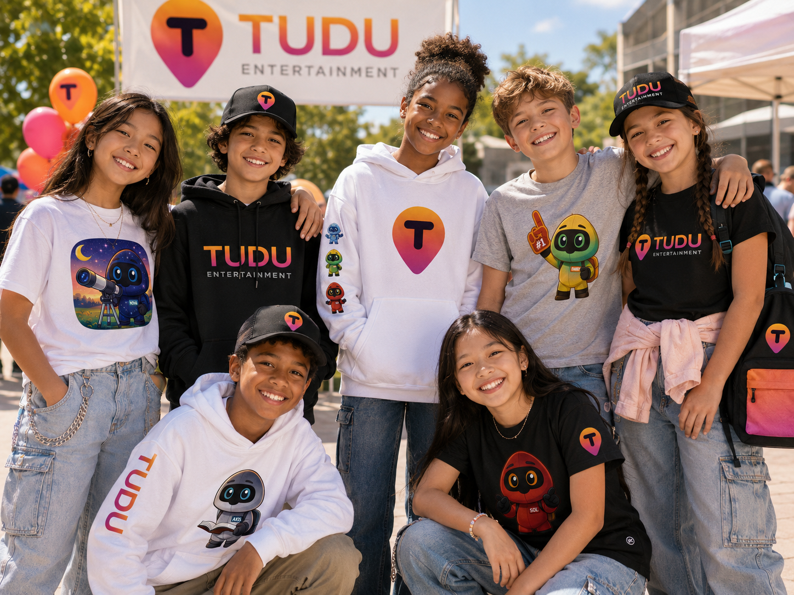
TUDU youth apparel featuring individual Tuduans characters

2.6 Keychains
Small, affordable character keychains — an easy impulse-buy or giveaway item, and a natural companion product to the plush toy line using the same character designs at a lower price point.

3. Brand Tie-In
Merchandise splits naturally into two brand tracks, and product lines should stay clearly organized around them:
Track | Products | Audience
TUDU Brand | Adult apparel, hats, general branded goods | Broad / adult TUDU users, TUDU Crew
Tuduans Characters | Plush toys, character backpacks, youth apparel, calendars | Kids, families, TUDU Kids Foundation

Direction note: Keep a consistent visual system so both tracks still feel like one brand — shared color palette, consistent logo placement, and the pin/T mark appearing somewhere on every product, even character-first ones.

4. Distribution & Sales Channels
- TUDU online store, for direct purchase and shipping.
- TUDU Event Marketplace — merchandise pre-ordered alongside event tickets, as outlined in the Event Marketplace strategy document.
- TUDU Kids Foundation tour stops — plush toys, backpacks, and stickers as giveaways or on-site sales during Foundation bus tours.
- TUDU Miles redemption — select merchandise items redeemable using TUDU Miles instead of cash, tying merchandise directly into the existing rewards economy.
Direction note: Decide which items (if any) are Miles-exclusive vs. cash-only vs. available through both paths, and at what Miles price point — this should stay consistent with the existing 800 Miles = $1 redemption rate used elsewhere in the Miles Economy.

5. Manufacturing & Fulfillment
Direction note: Identify manufacturing partners for soft goods (plush, backpacks) separately from apparel and printed goods (calendars, stickers) — these typically require different vendors and lead times.
Direction note: Decide on an inventory model: made-to-order/print-on-demand (lower risk, slower fulfillment) versus bulk manufacturing (faster fulfillment, higher upfront cost and storage needs).
Direction note: For youth apparel and plush toys specifically, confirm compliance with children's product safety standards (e.g., choking hazard testing for small parts, flammability standards for apparel) before manufacturing at scale.

6. Open Considerations
- What is the initial product launch order — which items go first (plush toys and backpacks appear to be the strongest character-driven starting point)?
- Will merchandise be sold only through TUDU's own channels, or also through third-party retailers/marketplaces?
- How does sizing work for youth vs. adult apparel, and will sizing data collected through the Event Marketplace pre-order flow feed into merchandise demand planning?
- Should each Tuduan have its own dedicated product variant across every category (e.g., a Nova backpack, a Nova tee, a Nova plush) to encourage collecting the full set?

